Setting up the DRT server

Install the Raspberry Pi Imager
- Open the https://www.raspberrypi.com/software/
- Choose the option “Download for Windows”.
- Double click on the downloaded executable and start installation.
- Click yes for administrative permission.
- Click on Install
- Click on Finish when done while the “Run Raspberry Pi Imager” is checked.

Flash an SD-Card

Choose Device
- Click on CHOOSE DEVICE from Imager main window.
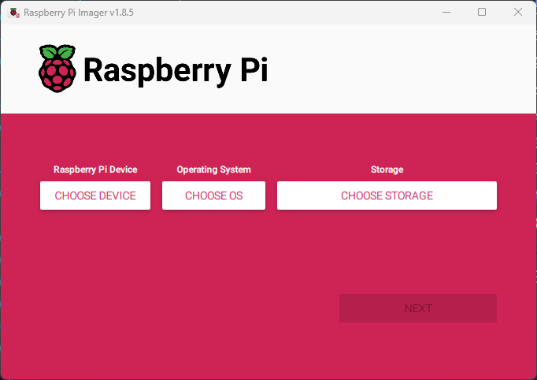
- From the list of the devices select Raspberry Pi 4

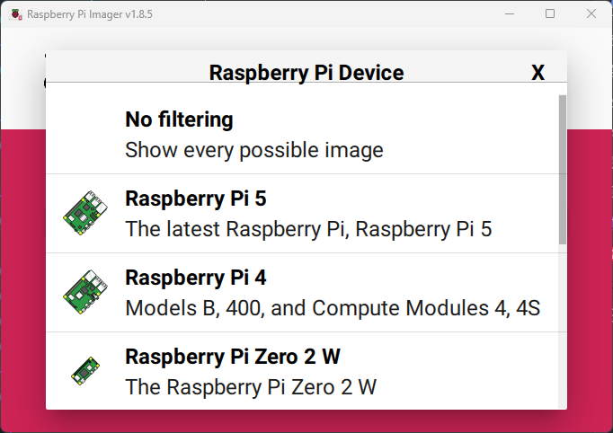

Choose OS
- Click on CHOOSE OS from Imager main window.
- From the Operating System list select Raspberry Pi OS (other)
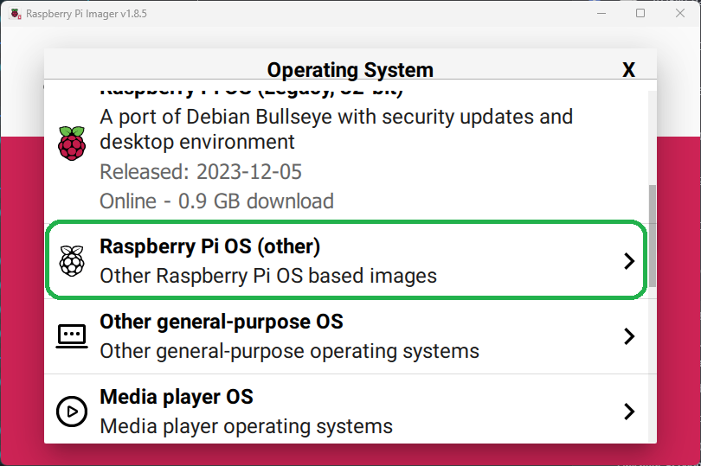
- Select the Raspberry Pi OS (Legacy, 64-bit) Lite from the next list.

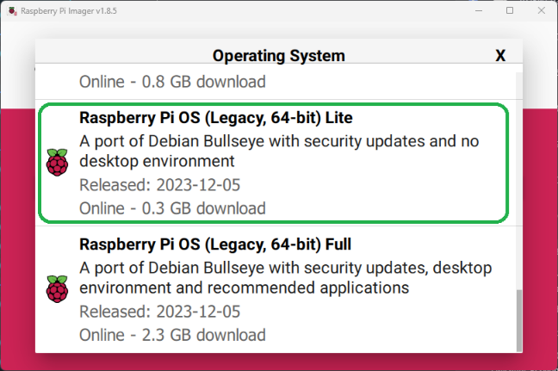
  - Note: A Legacy OS should be selected for the library and packages used by DRT Server that are not supported by the latest OS.

Choose Storage
- Insert an SD-Card
  - Note: Better to use minimum SD-Card size of 16GB.
  - In this document, an SD-Card with 128GB is used.
- Click on CHOOSE STORAGE from Imager main window.
  - Select your SD-Card from the Storage list.
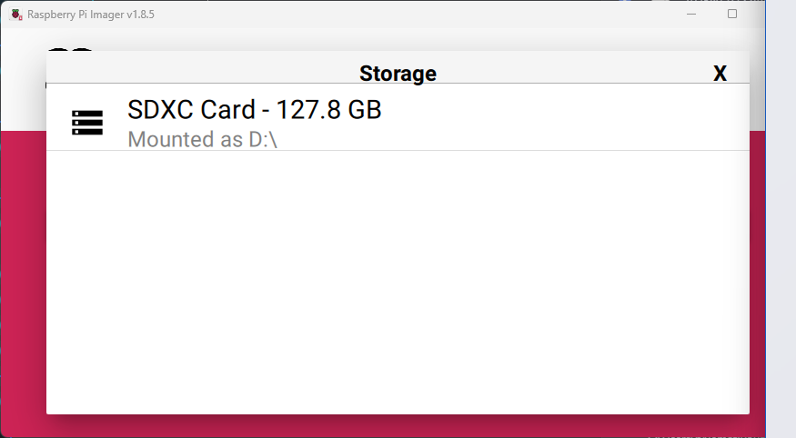

OS Customization

General
- Confirm that your final configured Imager options are as follows.
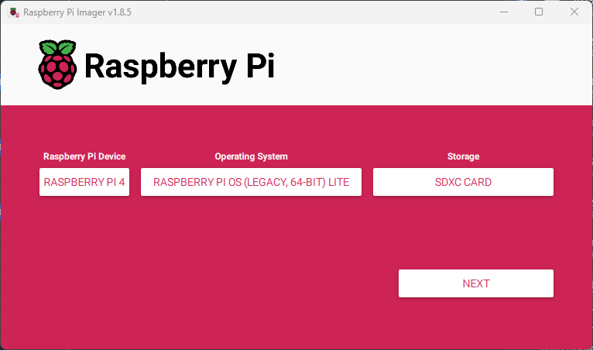

- Click on NEXT from Imager main window.
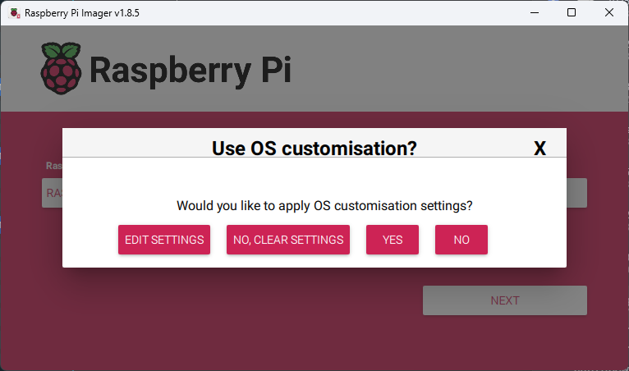
- Click on EDIT SETTINGS from the Use OS customization? Dialog.
- In the OS Customization screen enter the following

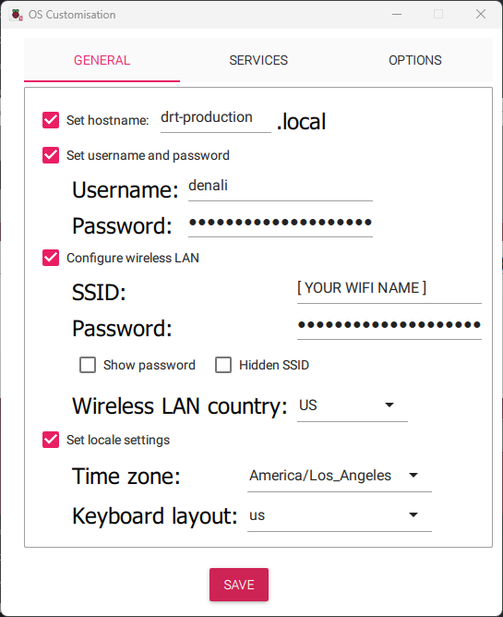
Host Name
- Check the Set hostname: field and enter the following:
  - Enter the ‘drt-’ concatenated with the DRT environment which is going to be configured on this server.
  - As an example ‘production’ has been entered in this case,
    - drt-production
  - Other options would be:
    - drt-staging
    - drt-quality
Note: the DRT hostname is very important and if it is not correctly named the installation and configuration will not work properly.

User definition
- Check the Set username and password field and enter the following:
  - Enter ‘denali’ in the Username: field.
  - Enter a secure password for the Password: field.

Wireless LAN
- Check the Configure wireless LAN field and enter the following:
  - Enter your Wi-Fi name in the SSID: field.
  - Enter your Wi-Fi password in the Password: field.
  - Choose US in the Wireless LAN country: field.

Local settings
- Check the Set locale settings field and enter the following:
  - Choose America/Los_Angeles in the Time zone: field.
  - Choose us in the Keyboard layout: field.

Services

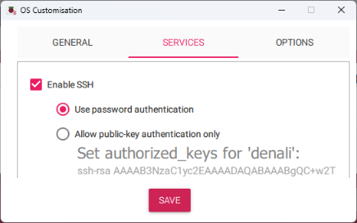
Enable SSH
- Check the Enable SSH field.
- Choose Use password authentication for the ssh service authentication.

Options
- [X] Check the Play sound when finished field.
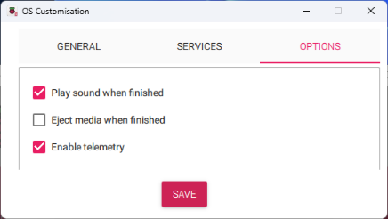
- [ ] Uncheck the Eject media when finished field.
- [X] Check the Enable telemetry field.
Note: During flashing the OS on the SD-Card, windows will display multiple prompts to format or not able to read the storage, that is because the format of the SD-Card partition(s) are not known to Windows, therefore you should ignore/cancel/close the dialog(s) in that case.

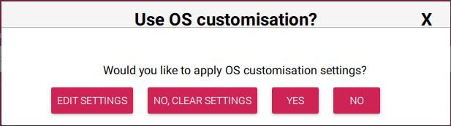
Finalizing
- When done click on the SAVE button.
- On the next dialog click on the YES button.
- Click on the YES button when asked to confirm continuing the SD card erase and data loss.

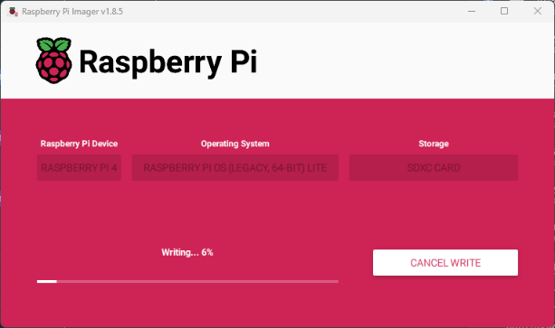
Writing Image
The Raspberry Pi Imager then will start writing the OS image on the chosen SD-Card with the selected customizations.

On successful SD-Card flash The Raspberry Pi Imager will prompt you to CONTINUE.
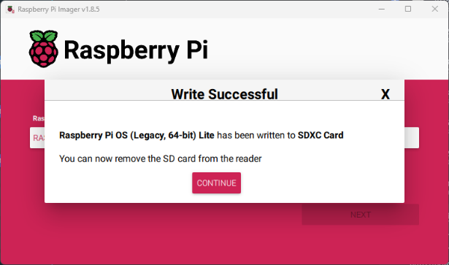
- Click on CONTINUE.

The SD-Card is now ready.

Copy the DRT Server on SD-Card

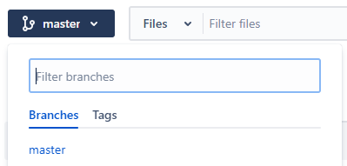
Download the DRT Server
The DRT Server should be downloaded from the following repository:
https://bitbucket.org/diality-cloud/drtserver/src/master/
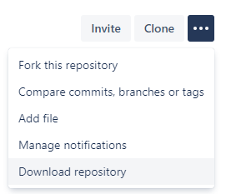
The repository by default is on the master branch, if needed choose a different branch as has been shown in the following image from the same page on the repository link.
On the same page, on the right, by selecting the Download Repository, download the source of the DRT server as has been shown in the following image.

Prepare the DRT-Server
Extract the downloaded zip file in the same location by right click on the file and select Extract All… from the drop-down menu and click on the Extract button on the popped-up dialog.
In the Opened Explorer rename the folder to drt-server.
 => 
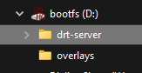
After flashing the OS on the SD-Card is done, since the Eject media when finished option is not checked, Windows will display the content of the SD-Card by loading the boot partition.

Move to SD-Card
Move the folder to the SD-Card boot partition which shall be currently loaded.
Select Eject from right click on the SD-Card then remove and insert the SD-Card in the Raspberry Pi SD-Card slot and turn the device on.

Setting up the DRT Server
After booting up the server the OS will start configuring with the customization settings that have been set during flashing the SD-Card.
Wait until the OS is done configuring. The DRT Server will automatically reboot 2 times, after it is powered on.
- When powered on will display a screen indicating Resizing root filesystem, Generating SSH keys…, and so on.
- Then we will do the first reboot, which will stay for a short period of time on the login prompt, therefore you need to be aware to not to try to log in.
- Then after will do the second reboot, which then will stay for a short period of time on the login prompt and will be ready when prompts on Finished Configure WLAN for rpi-imager.
Hit the enter key and log in with the username and password entered in the OS Customization.

Configuring the OS
After logging into the DRT Server execute the following command:
$ /boot/drt-server/install.sh
The install.sh which is deployed as part of the DRT Server package will do the following:
- Checking OS
  - Checks the DRT Server environment has been set correctly.
  - Checks the WLAN ip has been set correctly.
- Updating OS
  - Update the OS package repository.
  - Upgrade the installed packages.
- Installing curl
- Installing NodeJS
The NodeJS installation will prompt Script Deprecation Warning due to the old version of the package being used in this version of the DRT Server.
When prompted to Continue in 60 seconds, wait until 60 seconds passes and do not hit any key.
- Installing Redis Server
- DRT-Server Copy
Which copies the drt-server folder from the read-only bootfs to user home folder for later configurations.
- DRT-Server Install
- DRT-Server Configuration
Copies and modifies the DRT Server environment configuration files to work with the set environment.
- DRT-Server Build
- DRT-Server Autostart
Generates an execution manager script for the DRT Server and creates a Symlink of it in the user home folder.
- DRT-Server Cleanup
Removes the residual folders of the dry-demo which was only required during installation.
- Installation Summary
Which displays the following information:
  - Environment of the DRT Server
  - IP Address of the server
  - Node JS version
  - Redis Server version
- Installation Complete
Which means the installation is complete without error and DRT Server is ready to be used.

Setting Device Static IP address
Setting up the DRT Server is to register devices on the cloud to later connect as a valid device and communicate with the portal.
During the registration the DRT Server Portal will help to debug if the registration process is successfully done, and device is ready to use.
The DRT Server must be validated to communicate with portal and display registration progress.
One of the key pieces of information to validate the DRT Server is the IP Address and when it has been defined and set shall remain the same.
To make the IP Address persistent one of the ways is to define the static IP address.
The following steps need to be done to set the static IP address:
- [To be done later]
- …

Launching the DRT Server
During the installation an execution manager for the DRT Server is generated and a Symbolic link to it is created on the user home folder.
To launch the DRT Server run the following command:
$ ~/drt
The -h command line option can be used to get the list of available command line arguments and functionalities.

Backing up of the configured DRT server SD-Card
[To be done later]

